 | Damage requiring surveillance | UNSAFE  Unload as soon as possible | DANGER Unload immediately
Place a 1-meter metal ruler against the damaged component, with the damaged section aligned with the middle section of the ruler. Measure the gap between the upright frame column and the ruler.
Upright frame column (rear) | <5mm | 5-9mm | >10mm
Front upright column | <3mm | 3-5mm | >5mm
Diagonal/horizontal brace | <10mm | 10-19mm | >20mm

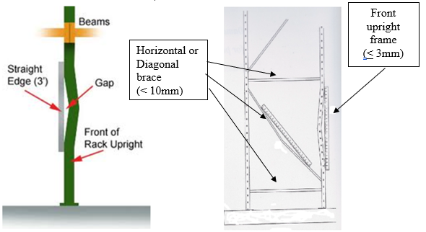
Beam Deflection:
Measure the span of your beam and divide by 180. That number will be your beam deflection allowance. Next measure from the outside of the beam, at the column, and the centre of the beam. Subtract the centre measurement from the outside measurement to determine if you are within the allowance.
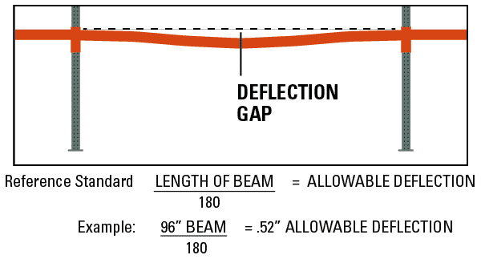

Comments / Diagrams:

